**Operating Systems Project Report**

|  |  |
| --- | --- |
| **Project Number (01 / 02 / 03):** | 01 |
| **Name:** | 呂苾瑄 |
| **Student ID:** | 0816057 |
| **YouTube link (Format youtube.com/watch?v=[key]):** |  |
| **Date (YYYY-MM-DD):** | 2021-10 |
| **Names of the files**  **uploaded to E3:** |  |
| **Physical Machine Total RAM (Example: 8.0 GB):** | 8GB |
| **Physical Machine CPU (Example: Intel i7-2600K):** | i5-1035G1 |

|  |  |
| --- | --- |
| **Checklist** | |
| **Yes/No** | **Item** |
|  | **The report name follows the format “OS_ProjectXX_StudentID.pdf”.** |
|  | **The report was uploaded to E3 before the deadline.** |
|  | **The YouTube video is public, and anyone with the link can watch it.** |
|  | **The audio of the video has a good volume.** |
|  | **The pictures in your report and video have a good quality.** |
|  | **All the questions and exercises were answered inside the report.** |
|  | **I understand that late submission is late submission, regardless of the time uploaded.** |
|  | **I understand that any cheating in my report / video / code will not be tolerated.** |

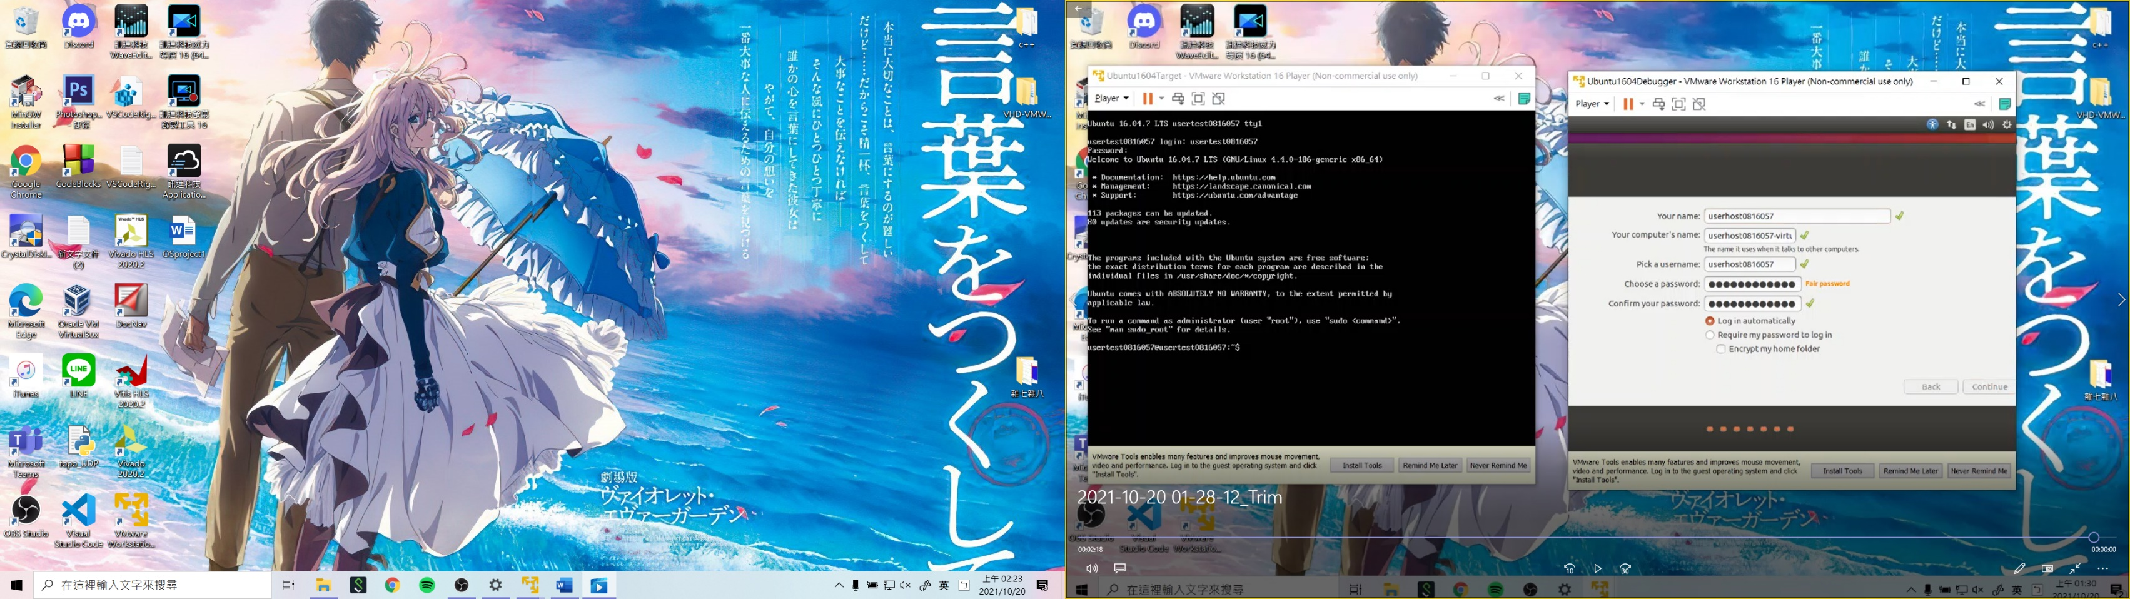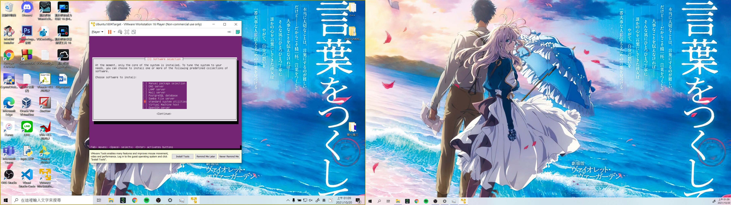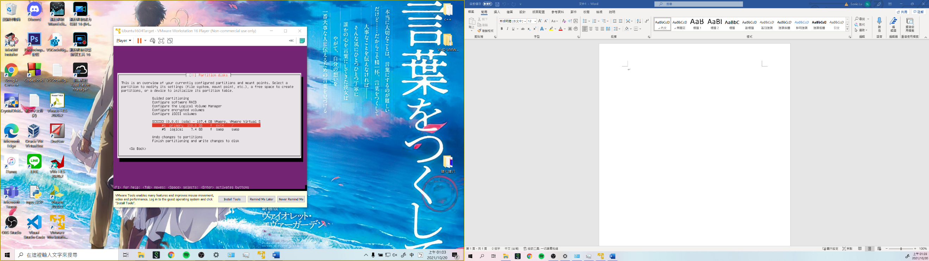Screenshot #1

Screenshot #2

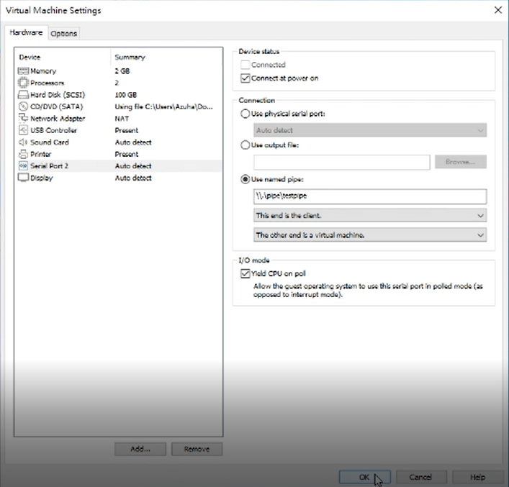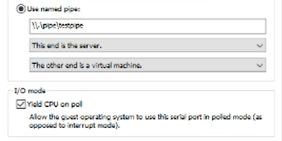

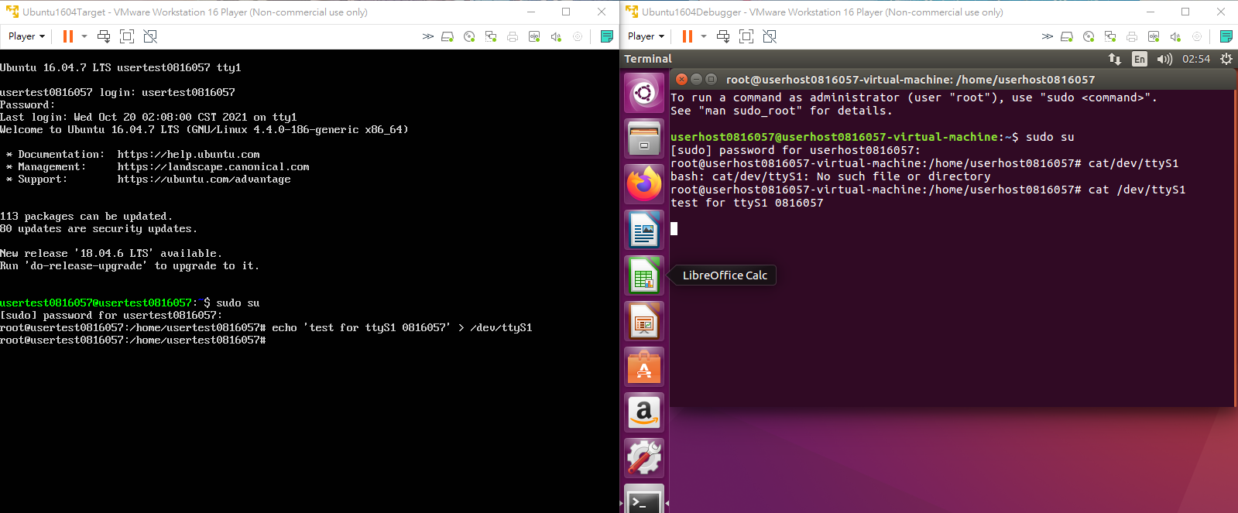



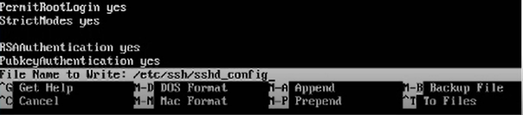

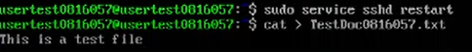



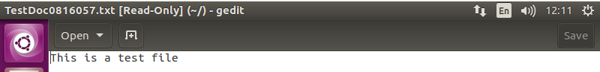

Screenshot #3









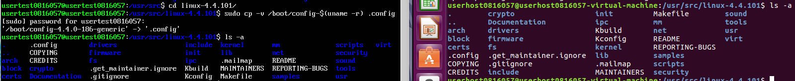



Screenshot #4

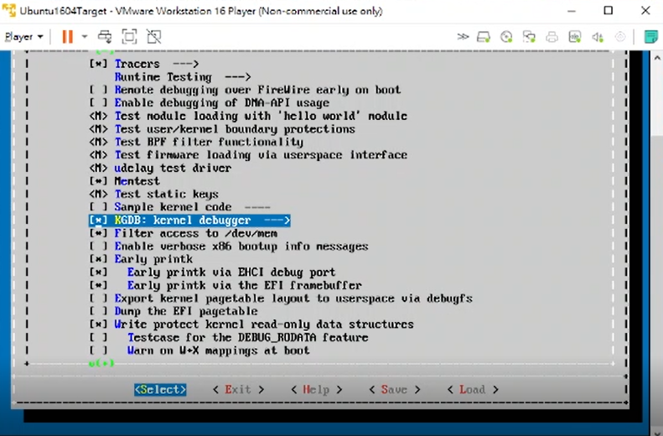

Screenshot #5

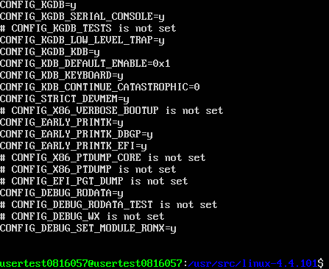

Screenshot #6

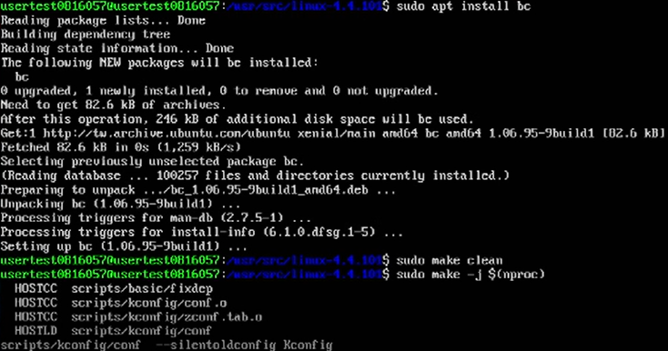

Screenshot #7

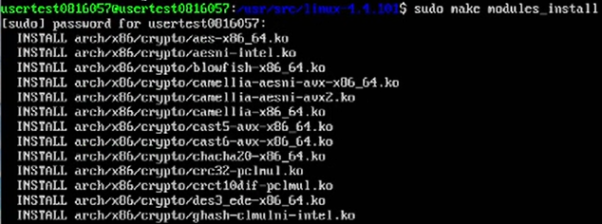

Screenshot #8

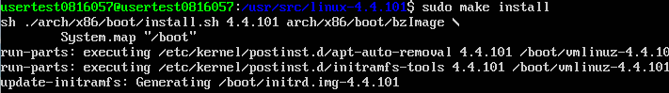

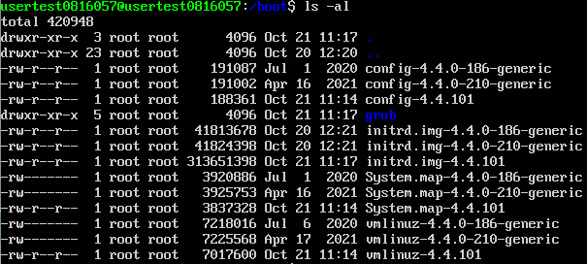

Screenshot #9



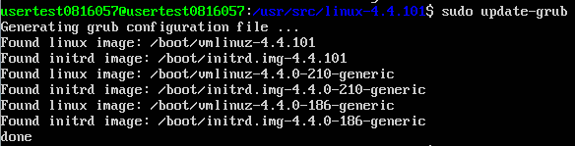

Screenshot #10

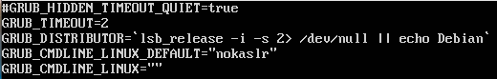

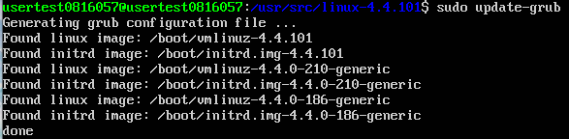

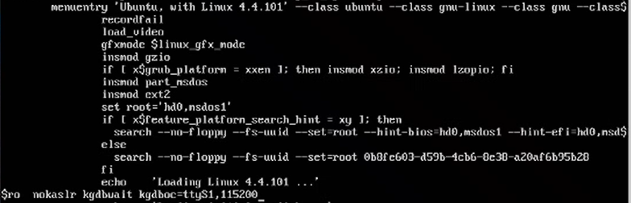



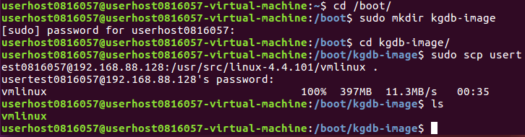

Screenshot #11

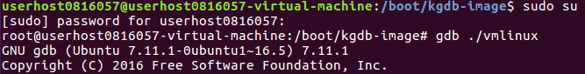

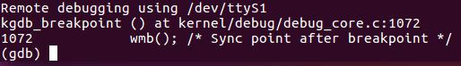

Screenshot #12

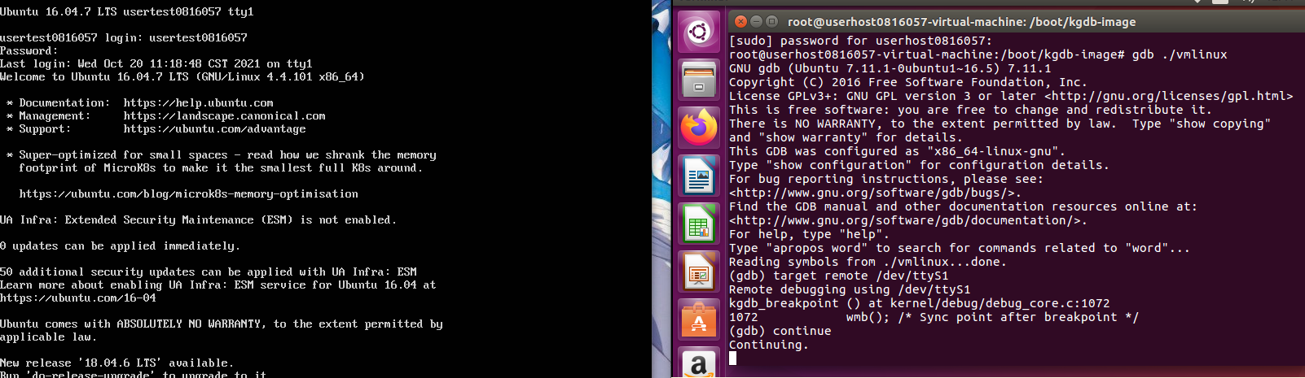

Screenshot #13

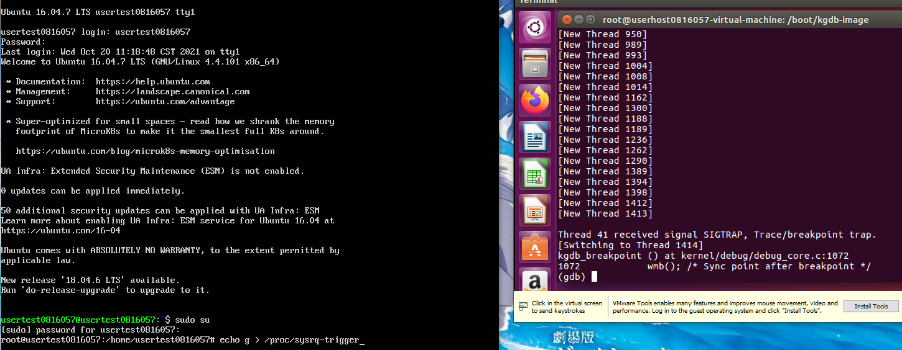

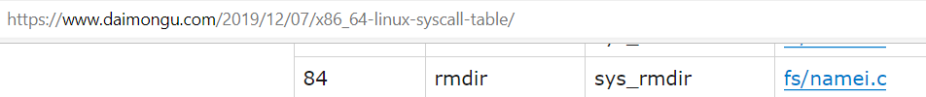



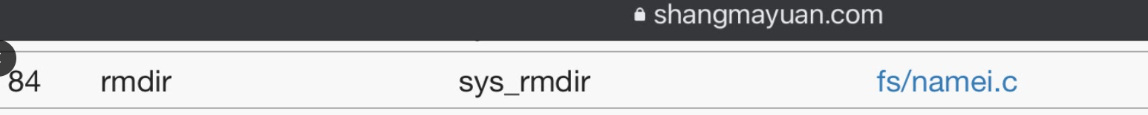

Screenshot #14

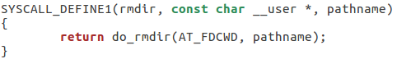

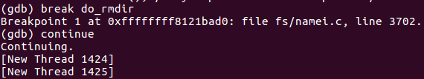

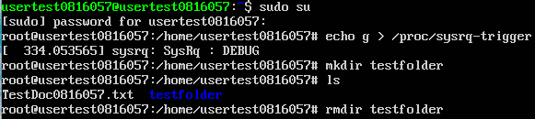

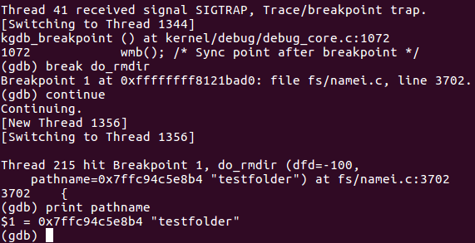

Screenshot #15

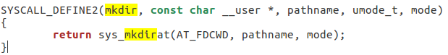

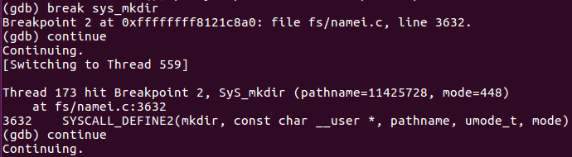

Screenshot #16

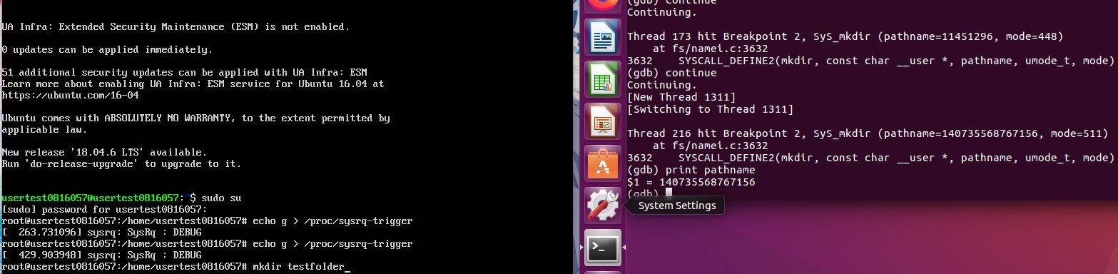



Screenshot #17

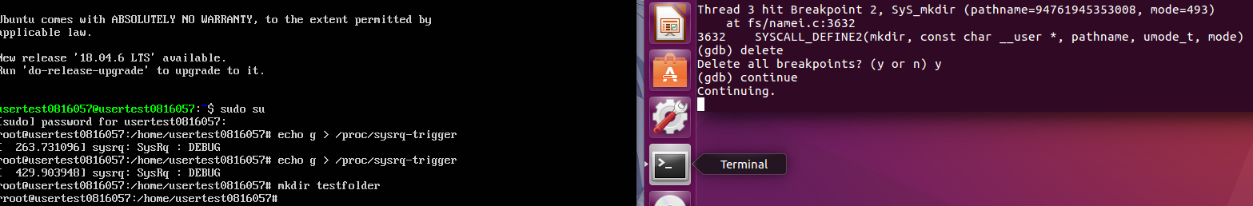



Screenshot #18

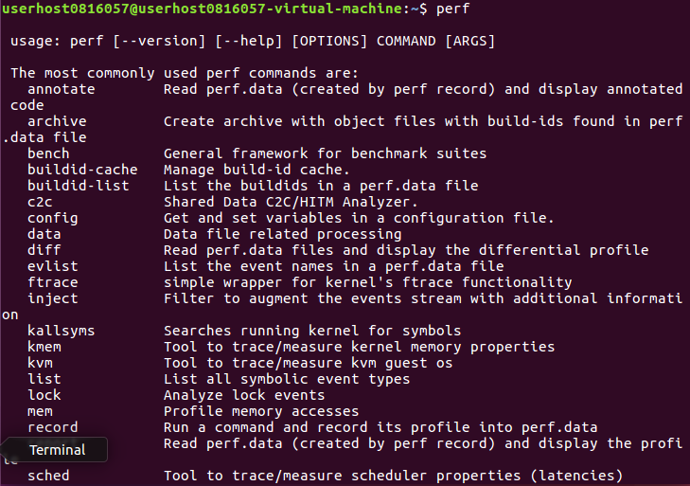

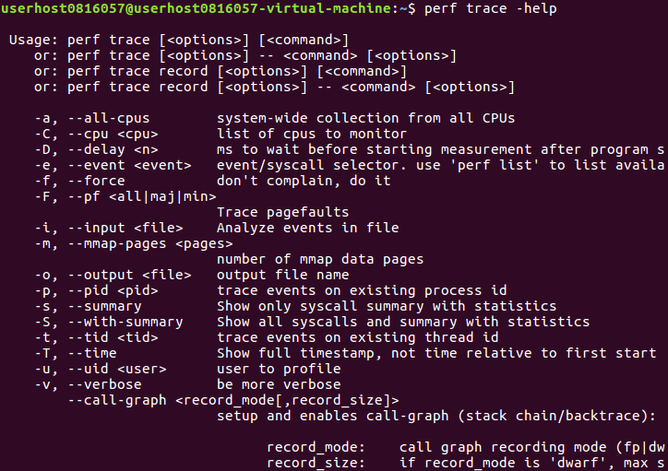

Screenshot #19

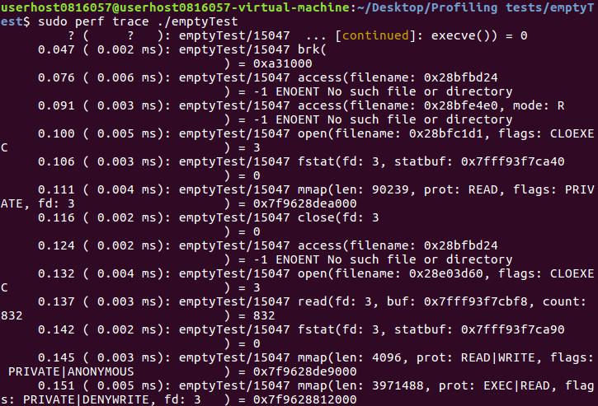

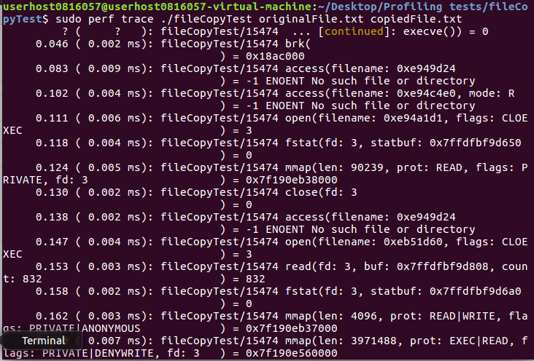

Screenshot #20

emptyTest.txt & fileCopyTest.txt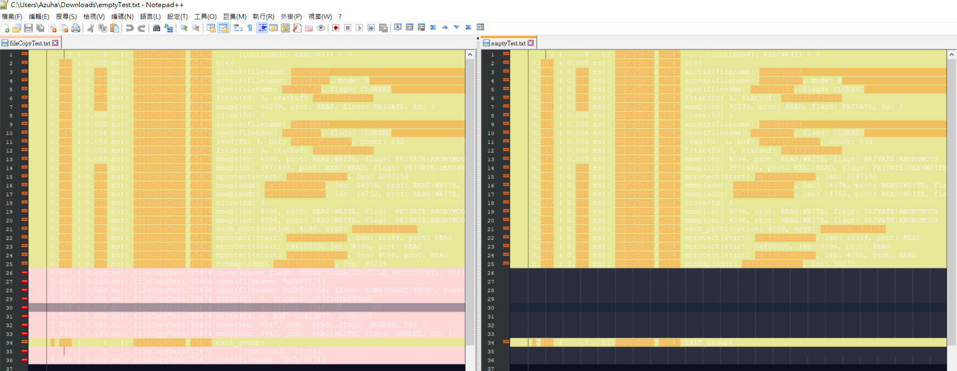



Screenshot #21

smallerFile: 4974bytes, originalFile: 9947bytes, biggerFile: 14923bytes

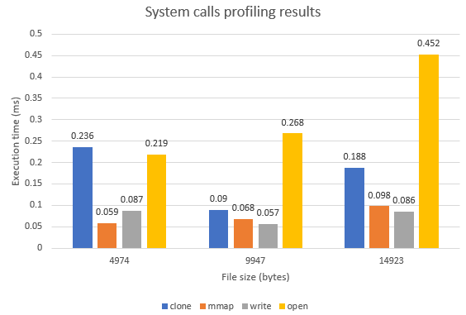

Screenshot #22

perf report

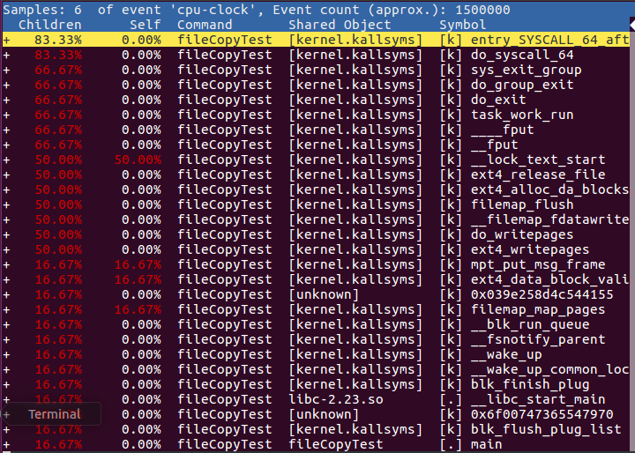

Screenshot #23,24

perf annotate

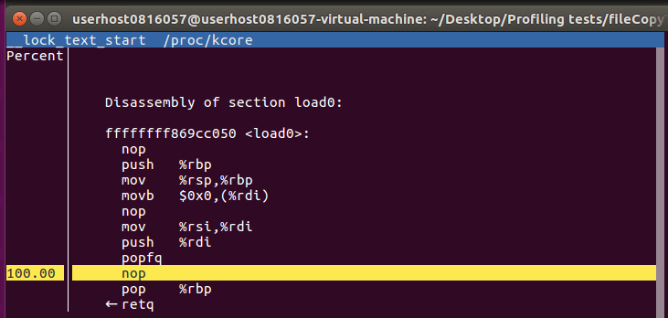

perf list

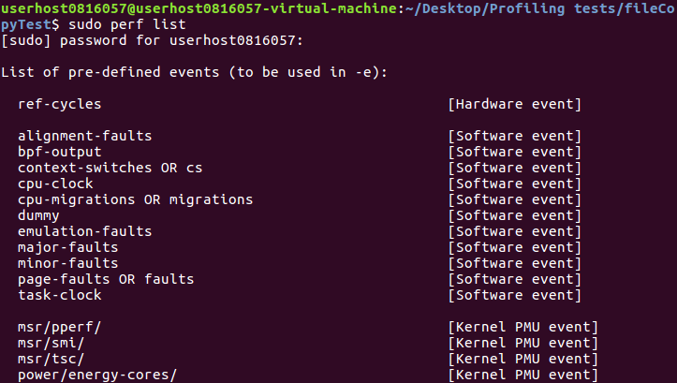

perf top

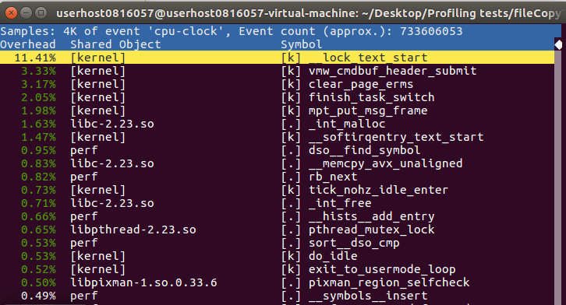

Questions

1. What is a Kernel? What are the differences between mainline, stable and longterm? What is a Kernel panic?

Kernel is a core of an operating system, and it has control over low-level task such as task management, disk management, memory management, the access to computer resource.

Mainline:

New features are introduced in new mainline kernels which released every 2-3 months. Mainline tree is maintained by Linus Torvalds.

Stable:

Kernel is called "stable" after each mainline kernel is released. Any bug fixes for a stable kernel are backported from the mainline tree and applied by a designated stable kernel maintainer. Stable kernel updates are released on as-needed basis, usually once a week.

Longterm:

Longterm maintenance kernel releases provided for the purposes of backporting bugfixes for older kernel trees. They don't release frequently, especially for older trees.

A kernel panic is when a computer detect an internal fatal error that is unable to safely recover or to continue to run the system. In this case, the kernel would print the messages as possible. The messages can be used to diagnose the problems.

2. What are the differences between building, debugging and profiling?

Building: compile the code into intermediate language, create or update the exe file, but doesn’t start the program.

Debugging: look for bugs and their causes, fix the wrong location or other downstream location to get correct output.

Profiling: a dynamic analysis process done on working code. Find slow routines in a program and optimize them.

3. What are GCC, GDB, and KGDB, and what they are used for?

GCC: the C and C++ compiler developed by GNU project, adopted as the default compiler of UNIX systems. It can compile the code into an executable file.

GDB: GNU Debugger. It can go through your code line by line or even instruction by instruction, allows you to see what’s going on inside the program while executing or at the moment it crashed. It provides the breakpoint function so we can set our breakpoint by ourselves to break the program.

KGDB: a source level debugger for the Linux kernel and the kernels of NetBSD and FreeBSD. It requires two connected machine. The target machine runs patched kernel and the host machine runs GDB.

4. What are the /usr/, /boot/, /home/, /boot/grub folders for?

/usr/: it has several subdirectories that contain additional UNIX commands and data files(the user binaries, their documentation, libraries, header files…), so it is one of the most important directories in the system.

/boot/: contains the files needed to boot the system. But the boot loader’s configuration files are in /etc with the other configuration files.

/home/: contains the user’s data files and user-specific configuration files. Each user only has write access to their own home folder. You need permissions (become the root user) to modify other files on the system.

/boot/grub/: GRUB stores its files here. The files are mostly modules, with configuration stored in grub.cfg.

5. What are the general steps to debug a Linux Kernel? (Add a figure)

Build the kernel with CONFIG_GDB_SCRIPTS enabled, but leave CONFIG_DEBUG_INFO_REDUCED off. ...

Install that kernel on the guest, turn off KASLR if necessary by adding “nokaslr” to the kernel command line. ...

Enable the gdb stub of QEMU/KVM, either. ...

cd /path/to/linux-build.

Start gdb: gdb vmlinux. ...

Attach to the booted guest

6. For this project, why do we need two virtual machines?

Because two machines are required for using KGDB. One machine(target) runs a kernel to be debugged. The other(host) runs GDB. We send debugging commands from host machine to target machine.

7. In Section 3.2, what are the differences between make, make modules_install and make install?

make: make is a rule-based scripting utility on UNIX used for compiling. It executes the default rule "all" when invoked without parameters. The rules are defined in the "Makefile" by default.

make modules_install: copies the compiled binaries (compile if not) and install into kernel's modules directory(/lib/modules/).

make install: the make program takes the binaries from the previous step and copies them into some appropriate locations so that they can be accessed.

8. In Section 3.3, what are the commands kgdbwait and kgdboc=ttyS1,115200 for?

kgdbwait: tells the kernel to wait on boot time, expecting someone to connect to it, and give further commands kgdboc

kgdboc: tells the kernel to use ttyS1 serial port and 115200 baud rate

9. What is grub? What is grub.cfg?

GRUB is a multi-boot bootloader, the first software that starts at a system boot. It allows you to select which operation system you want to start.

grub.cfg : the GRUB configuration file. It contains Bash-like code and a list of installed kernels in an array ordered by sequence of installation.

10. List at least 10 commands you can use with GDB.

help: get information about that topic

file: specifies which program you want to debug

run: executes the program under GDB

break: add breakpoints to stop the program execution temporary

delete: deletes all breakpoints that you have set

clear: delete the breakpoint set at a specific function

continue: set the program running again after a breakpoint triggers

step: runs the current source line and stops before executing the next one

next: runs the current source line (except function calls: be completely executed before execution stops again) with step execution will stop at the first line of the function that is called.

until: is like ‘next’, except that if you are at the end of a loop, it will continue execution until the loop is exited

list: print out some lines from the source code around linenumber

print: prints values of certain expressions

11. What is a kernel function? What is a system call?

kernel function: sets of different types of algorithms that are being used for pattern analysis. They are used to solve a non-linear problem by using a linear classifier.

system call: the programmatic way in which a computer program requests a service from the kernel of the operating system on which it is executed. It is the fundamental interface between a process and the operating system.

12. What is KASLR? What is it for?

KASLR: Kernel address space layout randomization. It is a technique to make exploits harder by placing objects’ addresses for the Linux kernel image at random at boot time, rather than fixed addresses. When compiled in, it can be disabled at boot time by specifying “nokaslr” as one of the kernel's boot parameters.

13. What are GDB’s non-stop and all-stop modes?

non-stop: when a thread stops to report a debugging event, only that thread is stopped. GDB does not stop other threads as well. Commands such as “continue” and “step” apply by default only to the current thread in non-stop mode.

all-stop modes: whenever your program stops under GDB for any reason, all threads of execution stop, not just the current thread.

14. Explain what the command echo g > /proc/sysrq-trigger does.

“sysrq” is a 'magical' key combo you can hit which the kernel will respond to regardless of whatever else it is doing unless it is completely locked up. The command g means the kernel and other software in the target machine is now stopped to used by kgdb (kernel debugger). Anything you type will be ignored.

15. What are these functions: clone, mmap, write and open?

clone: create a new (child) process, provide more precise control over what pieces of execution context are shared between the calling process and the child process.

mmap: establish a mapping between the virtual address space of the process for *len* bytes to the memory object represented by the file descriptor fildes at offset off for *len* bytes. The *prot* argument describes the desired memory protection of the mapping.

write: writes up to *count* bytes from the buffer starting at *buf* to the file referred to by the file descriptor *fd*.

open: opens the file specified by pathname.

16. Why is there no fork system call? What is the difference between fork and clone?

fork: creates a new child process, which is identical in almost every way of the parent process.

clone: creates a new child process. Various parameters of this system call, specify which parts of the parent process must be copied into the child process and which parts will be shared between them.

17.

smallerFile: 4974bytes, originalFile: 9947bytes, biggerFile: 14923bytes

a. Will the functions’ execution time be longer if the file is bigger?

Some functions don’t have large difference, some increase a little bit, and some decrease a little bit. According to the result, the function “open” increase when the file become larger.

b. How is the behavior of each function? Sort them from slowest to fastest.

According to the averaged result of the three files, from slowest to fastest: open, clone, write, mmap(write and mmap don’t have large difference).

c. Create a graph of file size (in bytes) vs. execution time (ms) of these four functions, using 3 different file sizes.



d. sudo perf report

i. What is it for?

Read perf.data (created by perf record) and display the profile as a summary. It builds a tree from the stack traces, coalescing common paths, and showing percentages for each path. You can go to the line you want to see and get more detailed information.

ii. For fileCopyTest, show and interpret the results.

The perf report output shows that 1500000 events were traced, mant of them are from the “fileCopyTest” command.

The overhead can be shown in two columns as Children and Self when perf collects callchains. The self overhead is simply calculated by adding all period values of the entry - usually a function (symbol). This is the value that perf shows traditionally and sum of all the self overhead values should be 100%.

The children overhead is calculated by adding all period values of the child functions so that it can show the total overhead of the higher level functions even if they don’t directly execute much. Children here means functions that are called from another (parent) function.

It might be confusing that the sum of all the children overhead values exceeds 100% since each of them is already an accumulation of self overhead of its child functions. But with this enabled, users can find which function has the most overhead even if samples are spread over the children.



e. Perf has more commands (Section 5.1 step 4). Select another command (besides report, trace and record), explain what is it for and show how to use it. Create your own scenario.